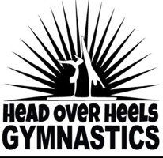

*A fun and healthy alternative to day care!*

Head Over Heels offers fun and flexible daytime programs for kids of all abilities (pre-school and up)! Children are grouped by age and ability, so whether you are just starting out or are an advanced gymnast, you will have both a fun and challenging experience here at Head Over Heels. HOH offers partial week options, family discounts, and an extended day program (great for working parents!)

HOH will help your child reach his or her PERSONAL BEST with:

* Fun weekly fitness challenges
* Skill-building clinics
* Ninja style challenges
* Strength and cardio activities

. . . all in our fully air-conditioned gym!

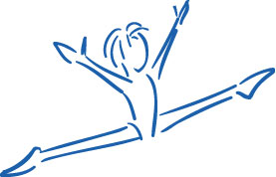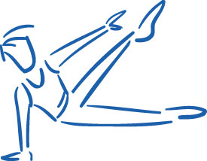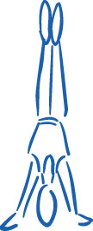

412 Washington Street, Norwell, MA 02061 ~ phone: 781-659-3378 fax: 781-659-9773

~ email: [HOHNorwell@gmail.com](mailto:HOHNorwell@gmail.com) www.HeadOverHeelsMA.com

Early drop-off is available anytime after 8:00 am until the start of the morning activities. Late day pick-up is available from the end of the day at 3:30 until 5:30 pm. The extended day program is not a structured part of our daily activities. Children may do quiet activities such as coloring or games or may bring a book from home (please no electronic devices). Children may also bring a snack from home.

**2020 Vacation/Summer Programs**

* February 17 – 21
* April 20 – 24
* June 22 – August 28

(Closed June 29 – July 3)

DAILY CAMP ACTIVITIES

Half Day:

* Group Activity Warm up
* Gymnastics Rotations
* Games / craft activity
* Popsicle break

Full Day:

* Lunch break (lunch and snacks not provided)
* Bus to Webb’s Pro Fitness for afternoon swimming
* Games / craft activities
* Gymnastics Rotations

Extended Day Program

**Half Day Program**

starting at ages 3.5/4

(must be potty-trained)

(9:30 – 12:00 pm)

Our morning program is dedicated entirely to gymnastics for children of all ages and levels - ranging from beginner through advanced. It is perfect for younger children who are not ready for a full day program. All students are placed appropriately by age and level. The half day program also includes open gym time and a popsicle break and younger gymnasts will be able to take a break mid-morning for craft time.

**Full Day Program**

ages 5 and up

(9:30 – 3:30 pm)

Beginner thru Advanced levels

Our full day program includes the same fun morning activities as the half day, including gymnastics rotations, and popsicle break.

Children who stay for the full day also enjoy lunch, games, arts and crafts, more gymnastics and **swimming at Webb’s Pro Fitness!**

**Full day students should bring a lunch, snack, bathing suit and towel.**